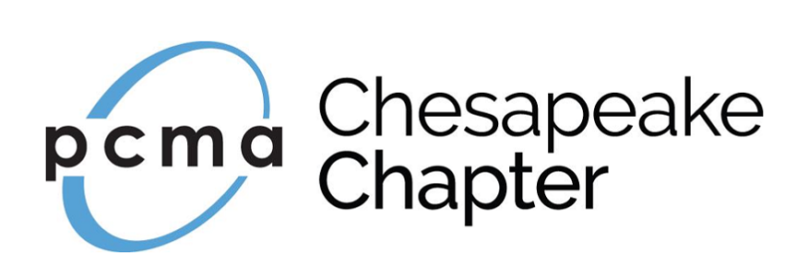

PCMA Chesapeake Chapter Administrator Application (2020)
The Chesapeake Chapter relies on the energy and enthusiasm of volunteers who are committed to working for the advancement of our Chapter and our industry. At this time, the Chesapeake Chapter is seeking applications for the 2020 Chapter Administrator.

Applications due August 30, 2019

To apply complete the enclosed application form and email to:
Patty Amos, Past President at pgamos@gmail.com.

Criteria & Guidelines for Selection of Administrator

The Chesapeake Chapter Board will consider the following guidelines:
- Participation in PCMA Chesapeake Chapter events and activities during last two years
- Responses to application questions
- Professional references, as provided during the application process.
- Prior volunteer leadership experience and committee participation.

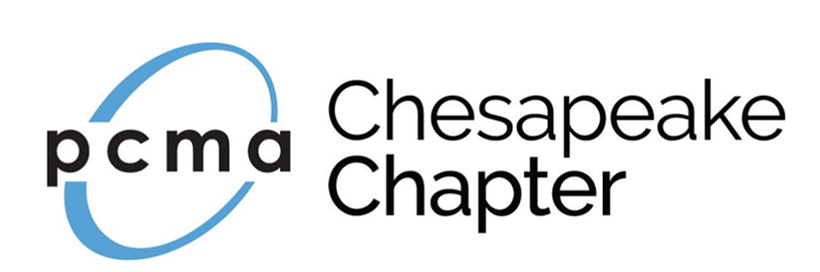

Chapter Administrator Job Description (2020 calendar year)

Administrative duties include the following:

- Create program invitations five (5) business days prior to the Thursday email blast delivery date (tentative schedule to be provided by Program Committee at Annual Board Meeting TBD November 2019)
- Work with the Program Committee to ensure deadlines are met and event details are complete
- Monitor event sign-up and fees and provide status reports to the Board
- Attend Chapter events
- Prepare and print name badges and meeting signage inserts prior to the event
- Set up, organize and oversee the management of the registration table on event site
- Place signage at event
- Create any name badges and collect attendee’s payments for onsite attendees
- Assist with event arrangements as requested by the Program Committee or the Board
- Send out calendar reminders for upcoming Board Meetings and monthly events after the annual Board Meeting
- Update the event program/Board meeting calendar throughout the calendar year
- Assist at Board meetings
- Send out communications to the Chapter as requested by Board
- Commit to attending/participating in scheduled board meetings to include two (2) in-person retreats in November and mid-Summer (locations and exact dates TBD); and additional monthly meetings by conference call
- Participate in training provided by PCMA HQ on the event software
- Provide suggestions to improve the registration invitation design and/or the process
- Adherence to the PCMA Principles of Professional Conduct
- Other duties as assigned

Compensation
- Contractor will receive a monthly payment of $375.00 and are considered a contract employee. Compensation is independent of PCMA.
- Paid administrators cannot vote or hold an office on the Board of Directors. However, they may, and are encouraged to, volunteer for non-voting roles and committees.
- Administrators who perform more than 50% of the chapter’s administrative duties will qualify for a complimentary PCMA membership. (Note: the current president will send an e-mail to Chapters@pcma.org in January requesting the complimentary membership for their administrator)

Hiring and dismissal

- The chapter administrator is contracted for one year (12 months) at a time.
- It is the discretion of the Board of Directors to continue or discontinue the contract with the current administrator each year.
- The Board may choose, at any time, to issue a call for a new administrator. The current administrator will be welcome to submit an application for review.
- At the annual November Board of Directors meeting, the board will vote on whether the current administrator is meeting the Board’s needs and will continue in their current position, if the contract with the administrator will be discontinued, or if a new administrator is to be selected for the upcoming year. (This vote will be done in confidence. The administrator should not be present. Voting will be in accordance with the by-laws and requires a quorum.)
- The contract between the administrator and the Board of Directors may be terminated following 60 days written notice by either party.

Board Application Form
PCMA Chesapeake Chapter Administrator (2020)

Applications due August 30, 2019

To apply complete the enclosed application form and email to:
Patty Amos, Past President at pgamos@gmail.com.
pgamos@gmail.com

1. Personal Information

First Name Last Name Credentials (if any)

Job Title

Company

Phone (mobile) Phone (office)

Email

Member of Chesapeake Chapter since (year)
2. Are you a:
- Meeting Planner
- Supplier
- Other (please explain)

3. How many PCMA Chesapeake Chapter events have you attended in the past two years?

4. What skills and/or connections would you bring to the table to benefit the PCMA Chesapeake Chapter? (250-word limit)

5. What would make you a valuable Chapter Administrator? (250-word limit)

6. Have you ever served on a volunteer committee or board of directors before? If yes, list organization, dates of service, and position(s) held. (100-word limit)

7. Describe how your current employer supports your involvement in professional development activities. (100-word limit)

8. Please provide the name, phone number, and email address of at least two people who can speak to your leadership experience and/or volunteer service record.

Reference #1 Name

Reference #1 - Phone Email

Reference #1 - How does this person know you?

Reference #2 Name

Reference #2 - Phone Email

Reference #2 - How does this person know you?

To apply: complete the enclosed application form and email to:
Patty Amos, Past President at pgamos@gmail.com.

